1. Addition of 2 Numbers
Aim
To write an 8085 assembly language program to add two 8-bit numbers and store the result in a specified memory location.
Procedure
- Load the first 8-bit number into the accumulator using the MVI instruction.
- Load the second number into register B.
- Add the contents of register B with the accumulator using the ADD instruction.
- The addition result is obtained in the accumulator.
- Store the result in the specified memory location using the STA instruction.
- Terminate the program using the HLT instruction.
Code
MVI A, 25H
MVI B, 15H
ADD B
STA 2050H
HLT
Output
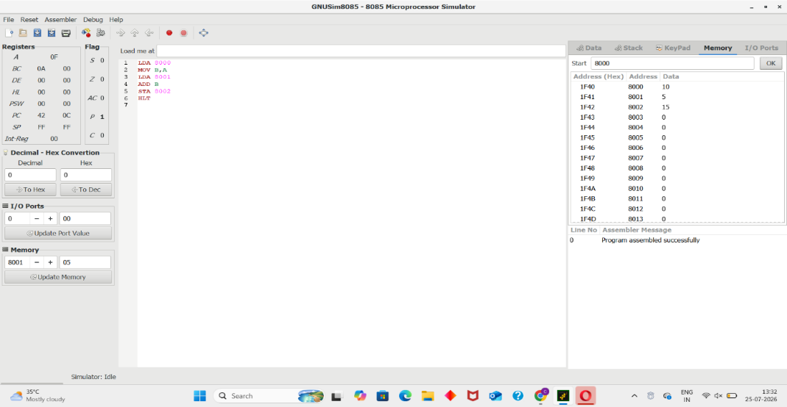
Result
The two 8-bit numbers are added successfully, and the result is stored at memory location 2050H.
2. Subtraction of 2 Numbers
Aim
To write an 8085 assembly language program to subtract two 8-bit numbers and store the result in a specified memory location.
Procedure
- Load the first number into the accumulator.
- Load the second number into register B.
- Subtract the contents of register B from the accumulator using the SUB instruction.
- The subtraction result is obtained in the accumulator.
- Store the result in the specified memory location using STA.
- Stop the program using the HLT instruction.
Code
MVI A, 25H
MVI B, 15H
SUB B
STA 2050H
HLT

Output
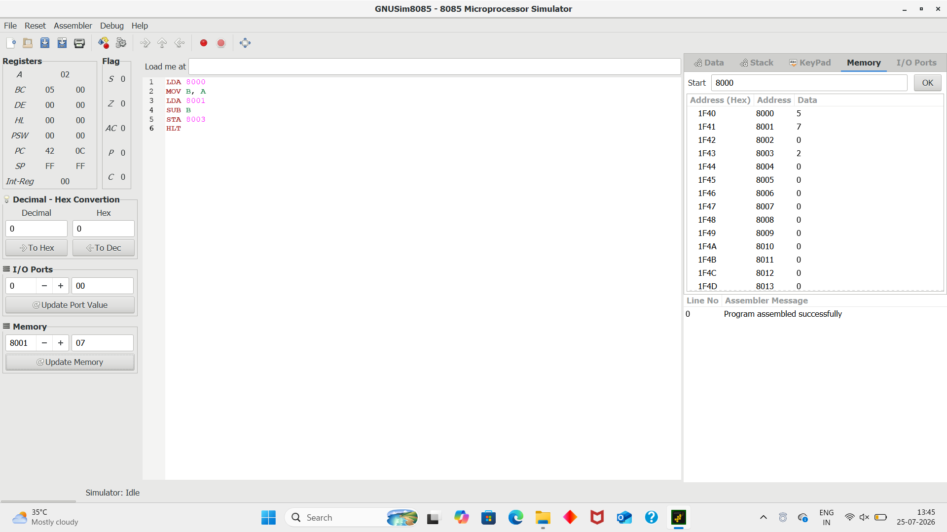
Result
The second number is successfully subtracted from the first number, and the result is stored at 2050H.
3. Addition with Carry
Aim
To write an 8085 assembly language program to add two 8-bit numbers and identify the carry generated during addition.
Procedure
- Load the first number into the accumulator.
- Load the second number into register B.
- Add both numbers using the ADD instruction.
- Check the Carry flag to determine whether a carry is generated.
- Store the sum in one memory location.
- Store the carry separately in another memory location.
- Stop the program using HLT.
Code
MVI A, FFH
MVI B, 02H
ADD B
STA 2050H

MVI A, 00H
ADC A
STA 2051H

HLT
Output
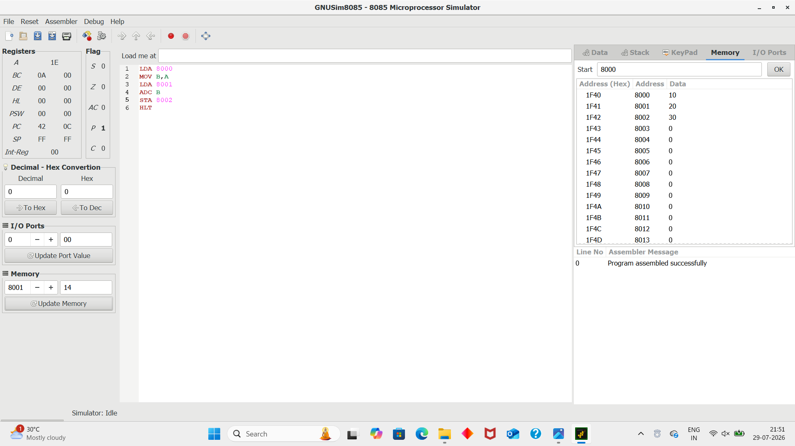

Result
The two numbers are added successfully. The sum is stored at 2050H and the carry is stored at 2051H.

4. Subtraction with Borrow
Aim
To write an 8085 assembly language program to subtract two 8-bit numbers and identify the borrow generated during subtraction.
Procedure
- Load the minuend into the accumulator.
- Load the subtrahend into register B.
- Perform subtraction using the SUB instruction.
- If the subtrahend is greater than the minuend, a borrow is generated.
- The borrow is indicated by the Carry flag in 8085 subtraction.
- Store the subtraction result and borrow information in memory.
- Stop the program using HLT.
Code
MVI A, 25H
MVI B, 30H
SUB B
STA 2050H

MVI A, 00H
ADC A
STA 2051H

HLT
Output
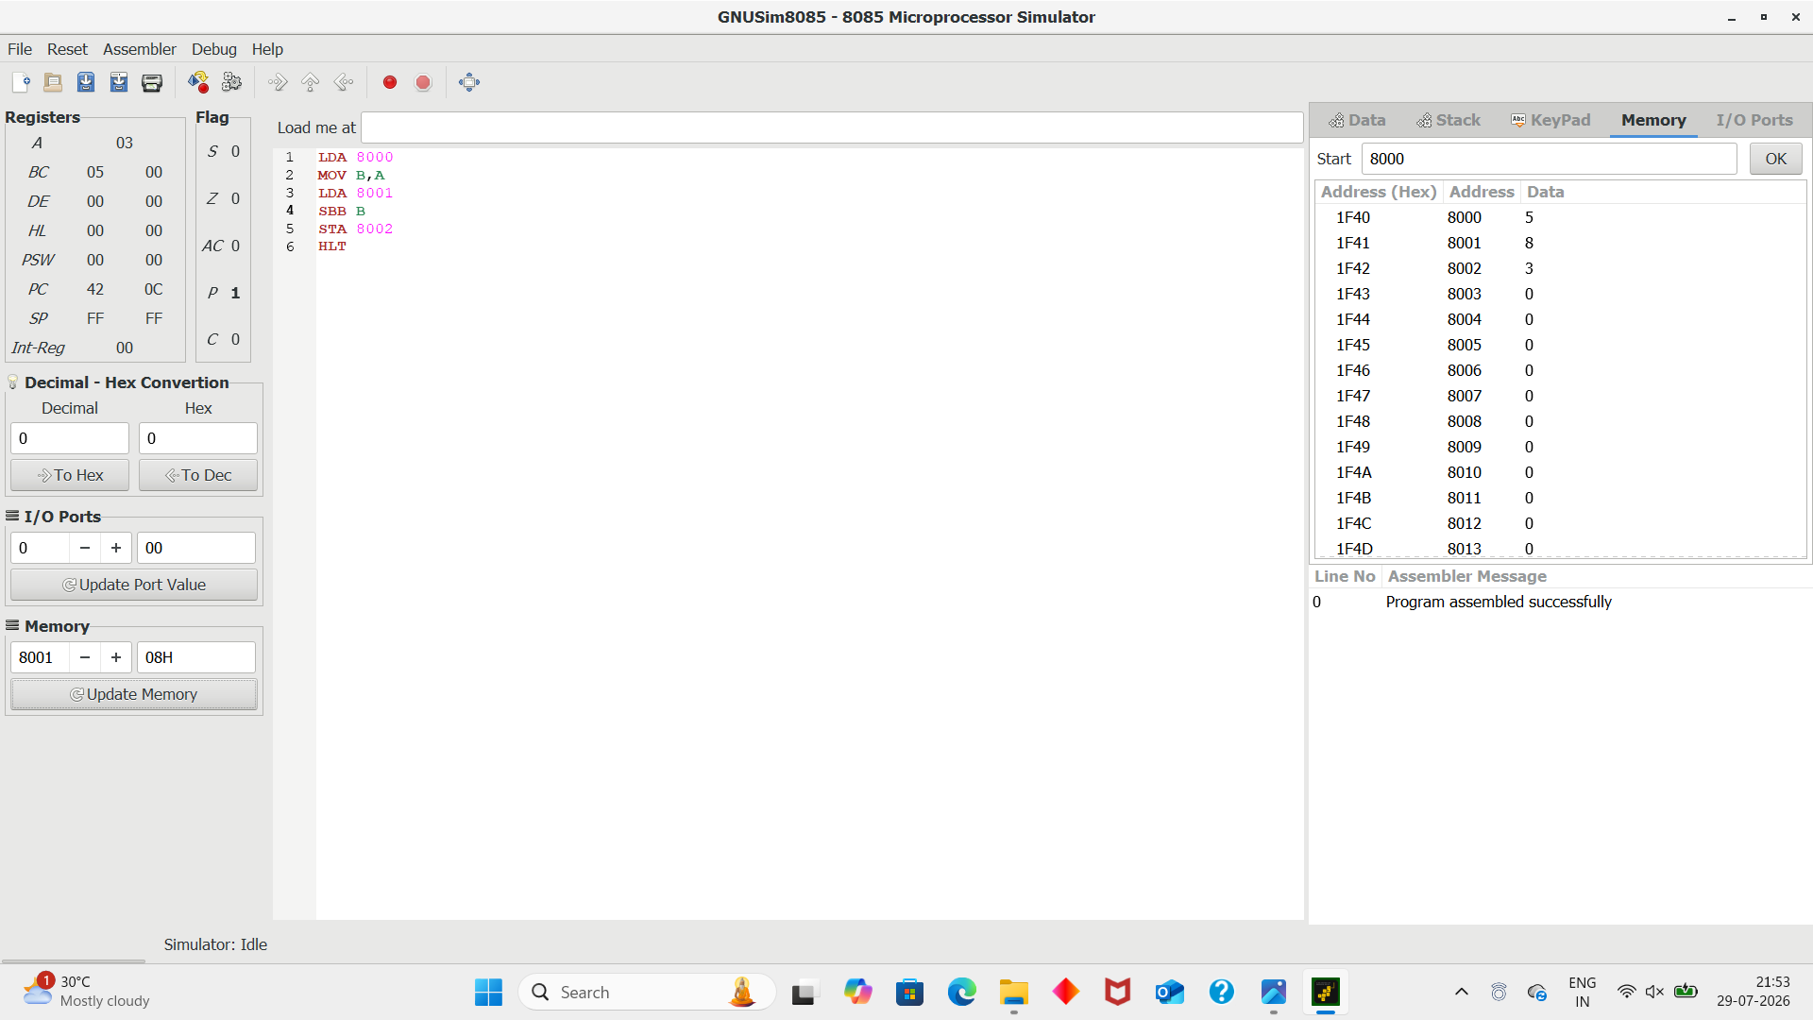
Result
The subtraction is performed successfully, and the result and borrow information are stored in memory.

5. Multiplication of 2 Numbers
Aim
To write an 8085 assembly language program to multiply two 8-bit numbers using repeated addition.
Procedure
- Load the first number into register B.
- Load the second number into register C and use it as the counter.
- Initialize the accumulator with zero.
- Add the contents of register B to the accumulator repeatedly.
- Decrement the counter after every addition.
- Continue the process until the counter becomes zero.
- Store the final product in the specified memory location.
- Terminate the program using HLT.
Code
MVI B, 05H
MVI C, 04H
MVI A, 00H

LOOP: ADD B
DCR C
JNZ LOOP
STA 2050H
HLT
Output
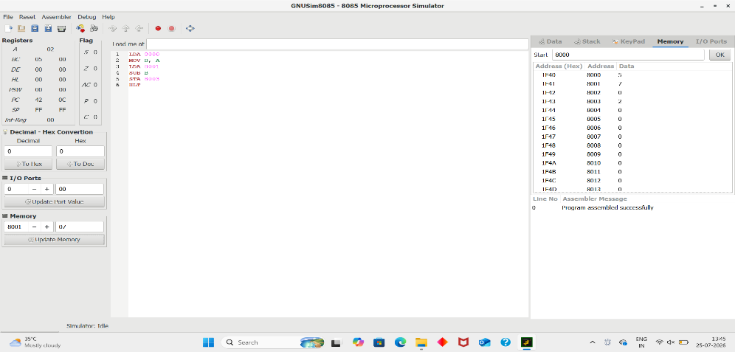
Result
The two numbers are successfully multiplied using repeated addition, and the product is stored at 2050H.

6. Division of 2 Numbers with Remainder
Aim
To write an 8085 assembly language program to divide two 8-bit numbers and find both quotient and remainder.
Procedure
- Load the dividend into register B.
- Load the divisor into register C.
- Initialize register D to zero for storing the quotient.
- Compare the dividend with the divisor using CMP.
- Repeatedly subtract the divisor from the dividend.
- Increment the quotient after every successful subtraction.
- When the dividend becomes smaller than the divisor, the remaining value is the remainder.
- Store the quotient and remainder in separate memory locations.
- Stop the program using HLT.
Code
MVI B, 17H
MVI C, 05H
MVI D, 00H

LOOP: MOV A, B
CMP C
JC EXIT
SUB C
MOV B, A
INR D
JMP LOOP

EXIT: MOV A, D
STA 2050H

MOV A, B
STA 2051H

HLT
Output
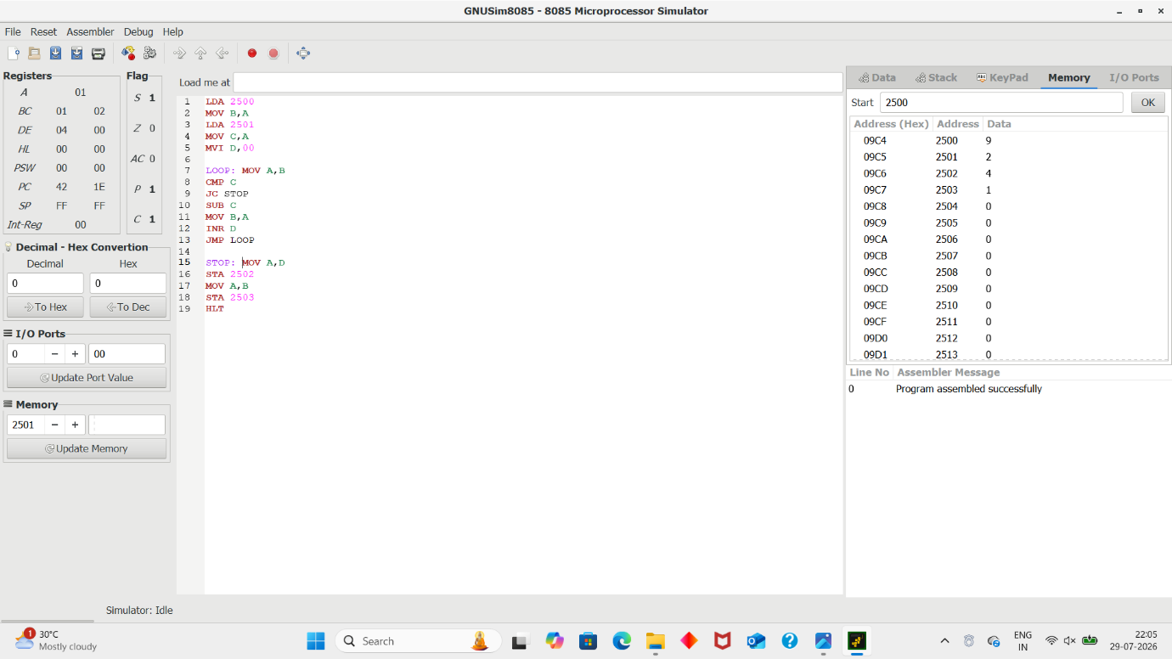

Result
The division is successfully performed.
- Quotient → 2050H
- Remainder → 2051H
For the given example:
17H ÷ 05H = 04H remainder 03H

7. Division of 2 Numbers Without Remainder
Aim
To write an 8085 assembly language program to divide two numbers and obtain the quotient when the division is exact.
Procedure
- Load the dividend into register B.
- Load the divisor into register C.
- Initialize register D to zero for storing the quotient.
- Subtract the divisor repeatedly from the dividend.
- Increment register D after every successful subtraction.
- Continue until the dividend becomes zero.
- The value in register D represents the quotient.
- Store the quotient in the specified memory location.
- Stop the program using HLT.
Code
MVI B, 14H
MVI C, 02H
MVI D, 00H

LOOP: MOV A, B
SUB C
MOV B, A
INR D
MOV A, B
JNZ LOOP

MOV A, D
STA 2050H
HLT
Output
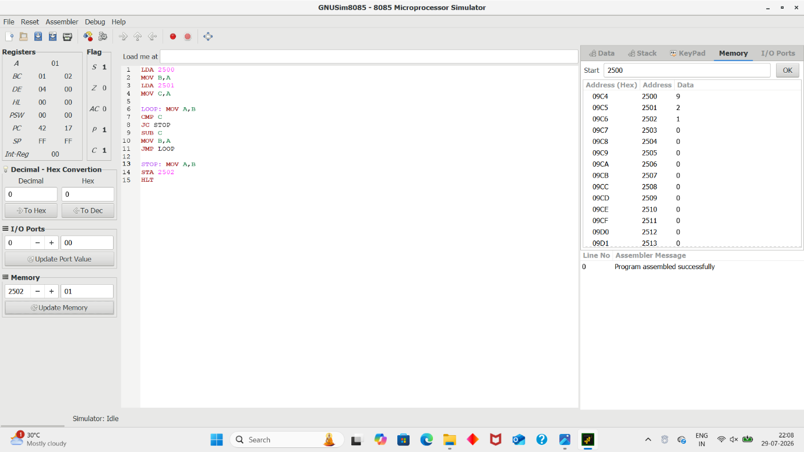
Result
The division is successfully performed without a remainder.
14H ÷ 02H = 0AH
The quotient 0AH is stored at 2050H.

8. Find Greatest Among 2 Numbers
Aim
To write an 8085 assembly language program to find the greatest among two 8-bit numbers.
Procedure
- Load the first number into the accumulator.
- Load the second number into register B.
- Compare both numbers using the CMP instruction.
- Check the condition flags to determine which number is greater.
- If the second number is greater, move it into the accumulator.
- Store the greatest number in the specified memory location.
- Stop the program using HLT.
Code
MVI A, 25H
MVI B, 35H

CMP B
JNC GREATER

MOV A, B

GREATER: STA 2050H
HLT

Output
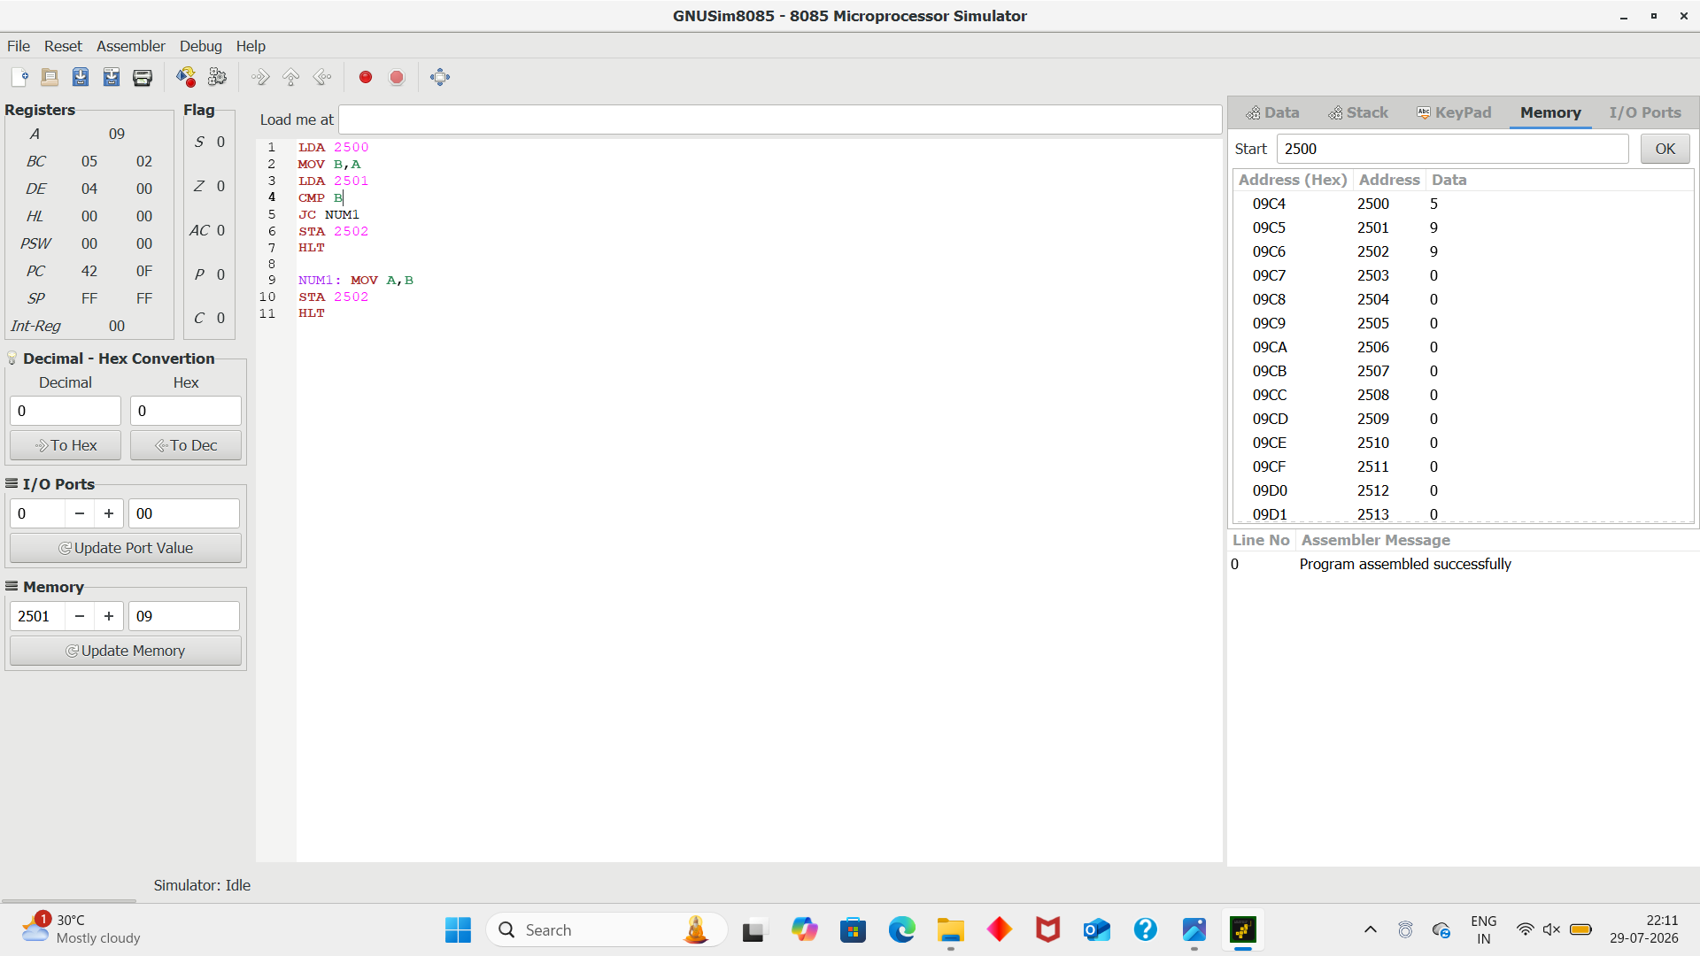
Result
The greatest of the two numbers is successfully found and stored at 2050H.
For the given values:
Greatest = 35H

9. Find Smallest Among 2 Numbers
Aim
To write an 8085 assembly language program to find the smallest among two 8-bit numbers.
Procedure
- Load the first number into the accumulator.
- Load the second number into register B.
- Compare the two numbers using the CMP instruction.
- Check the Carry flag to determine whether the first number is smaller.
- If the second number is smaller, move it into the accumulator.
- Store the smallest number in the specified memory location.
- Terminate the program using HLT.
Code
MVI A, 25H
MVI B, 35H

CMP B
JC SMALL

MOV A, B

SMALL: STA 2050H
HLT

Output
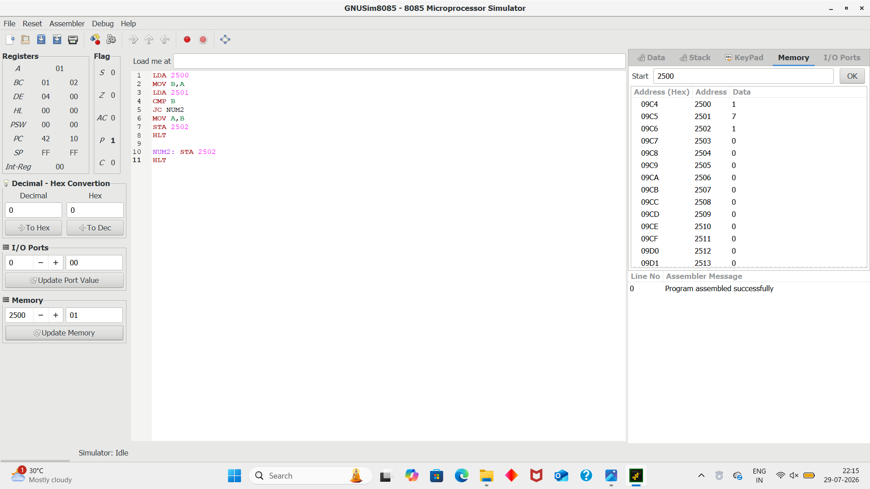
Result
The smallest of the two numbers is successfully found and stored at 2050H.
For the given values:
Smallest = 25H

10. Swapping of 2 Numbers
Aim
To write an 8085 assembly language program to swap two 8-bit numbers.
Procedure
- Load the first number into register B.
- Load the second number into register C.
- Use register D as a temporary register.
- Move the contents of B into D.
- Move the contents of C into B.
- Move the original value stored in D into C.
- Thus, the contents of B and C are exchanged.
- Store the swapped values in memory locations.
- Stop the program using HLT.
Code
MVI B, 25H
MVI C, 35H
MOV D, B
MOV B, C
MOV C, D
MOV A, B
STA 2050H
MOV A, C
STA 2051H
HLT
Output
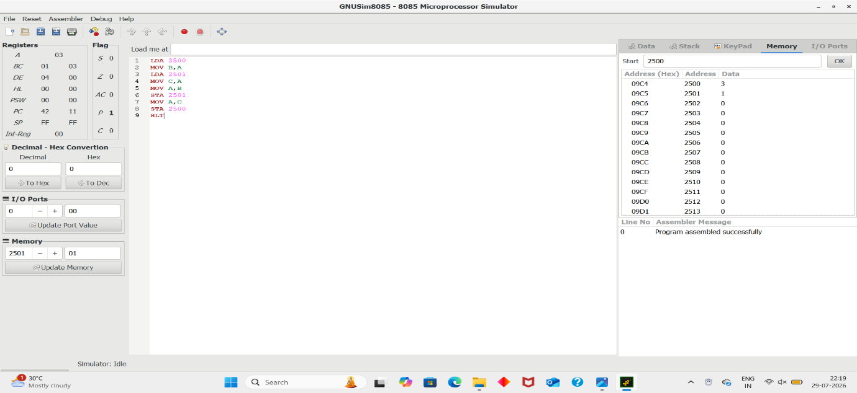

Result
The two numbers are successfully swapped.
Before: B = 25H, C = 35H
After: B = 35H, C = 25H

10) Check Whether a Number is Positive or Negative
Aim:
To write and execute an 8085 assembly language program to determine whether a given 8-bit number is positive or negative.
Procedure:
- Store the given number in memory location 2500H.
- Load the number into the accumulator using LDA 2500.
- Use ANI 80H to check the most significant bit (MSB).
- If the MSB is 0, the number is positive.
- If the MSB is 1, the number is negative in 2's complement representation.
- Store the result in memory location 2501H.
- Stop the program using HLT.
Code:
LDA 2500
ANI 80H
JZ POSITIVE
MVI A,01
STA 2501
HLT
POSITIVE: MVI A,00
STA 2501
HLT
Output:
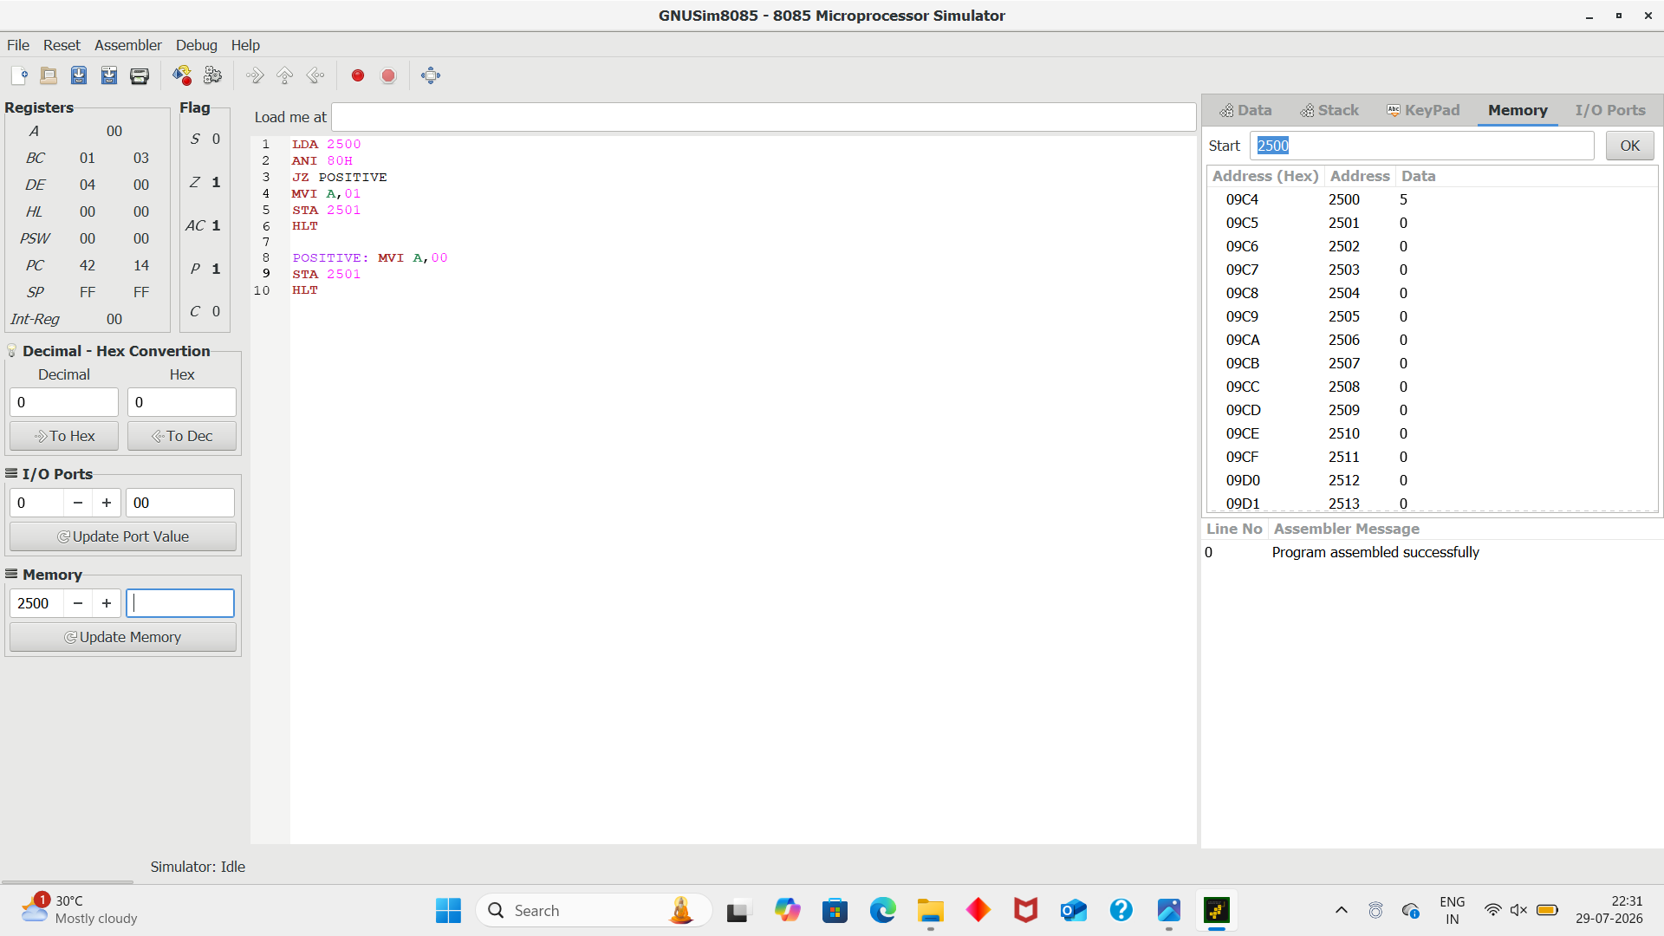
Result
For the given value in your screenshot:
Input = 05H
05H = 0000 0101
- MSB = 0
- Therefore, 05H is a positive number.
- 2501H = 00H indicates Positive.
Result: The given number 05H is positive

11) Find 1's Complement of a Number
To write and execute an 8085 assembly language program to find the 1's complement of an 8-bit number stored in memory location 2500H and store the result in 2501H.
Procedure
- Enter the 8-bit number in memory location 2500H.
- Load the number from 2500H into the accumulator using LDA.
- Apply the CMA instruction to complement all the bits of the accumulator.
- Store the complemented result in memory location 2501H using STA.
- Stop the program using HLT.
- Check the result stored at 2501H.
Code
LDA 2500
CMA
STA 2501
HLT
Output:
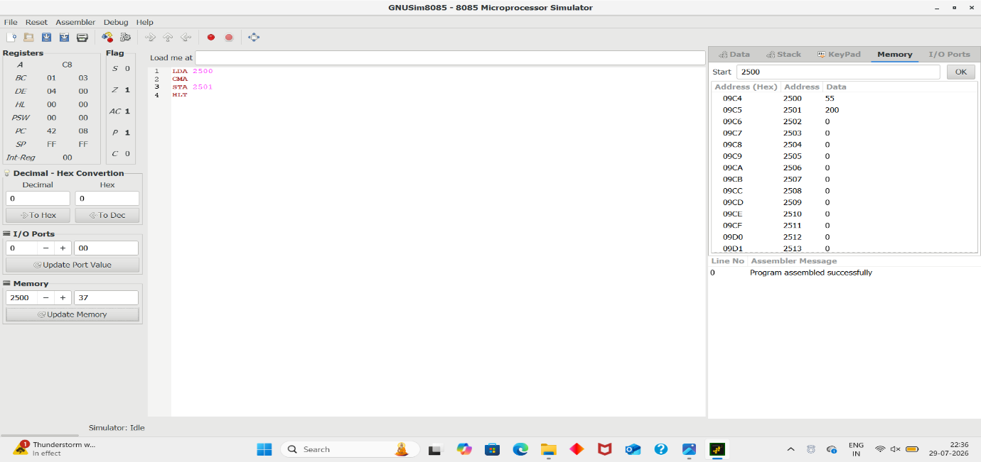

Result
Given number:
2500H = 55H
Binary representation:
55H = 0101 0101
After CMA:
1010 1010 = AAH

12) Find 2's Complement of a Number
Aim
To write and execute an 8085 assembly language program to find the 2's complement of an 8-bit number stored in memory location 2500H and store the result in 2501H.
Procedure
- Enter the 8-bit number in memory location 2500H.
- Load the number into the accumulator using LDA.
- Use the CMA instruction to find its 1's complement.
- Add 01H to the complemented value using ADI 01.
- Store the final result in memory location 2501H.
- Stop the program using HLT.
- Check the result stored at 2501H.
Code
LDA 2500
CMA
ADI 01
STA 2501
HLT
Output:
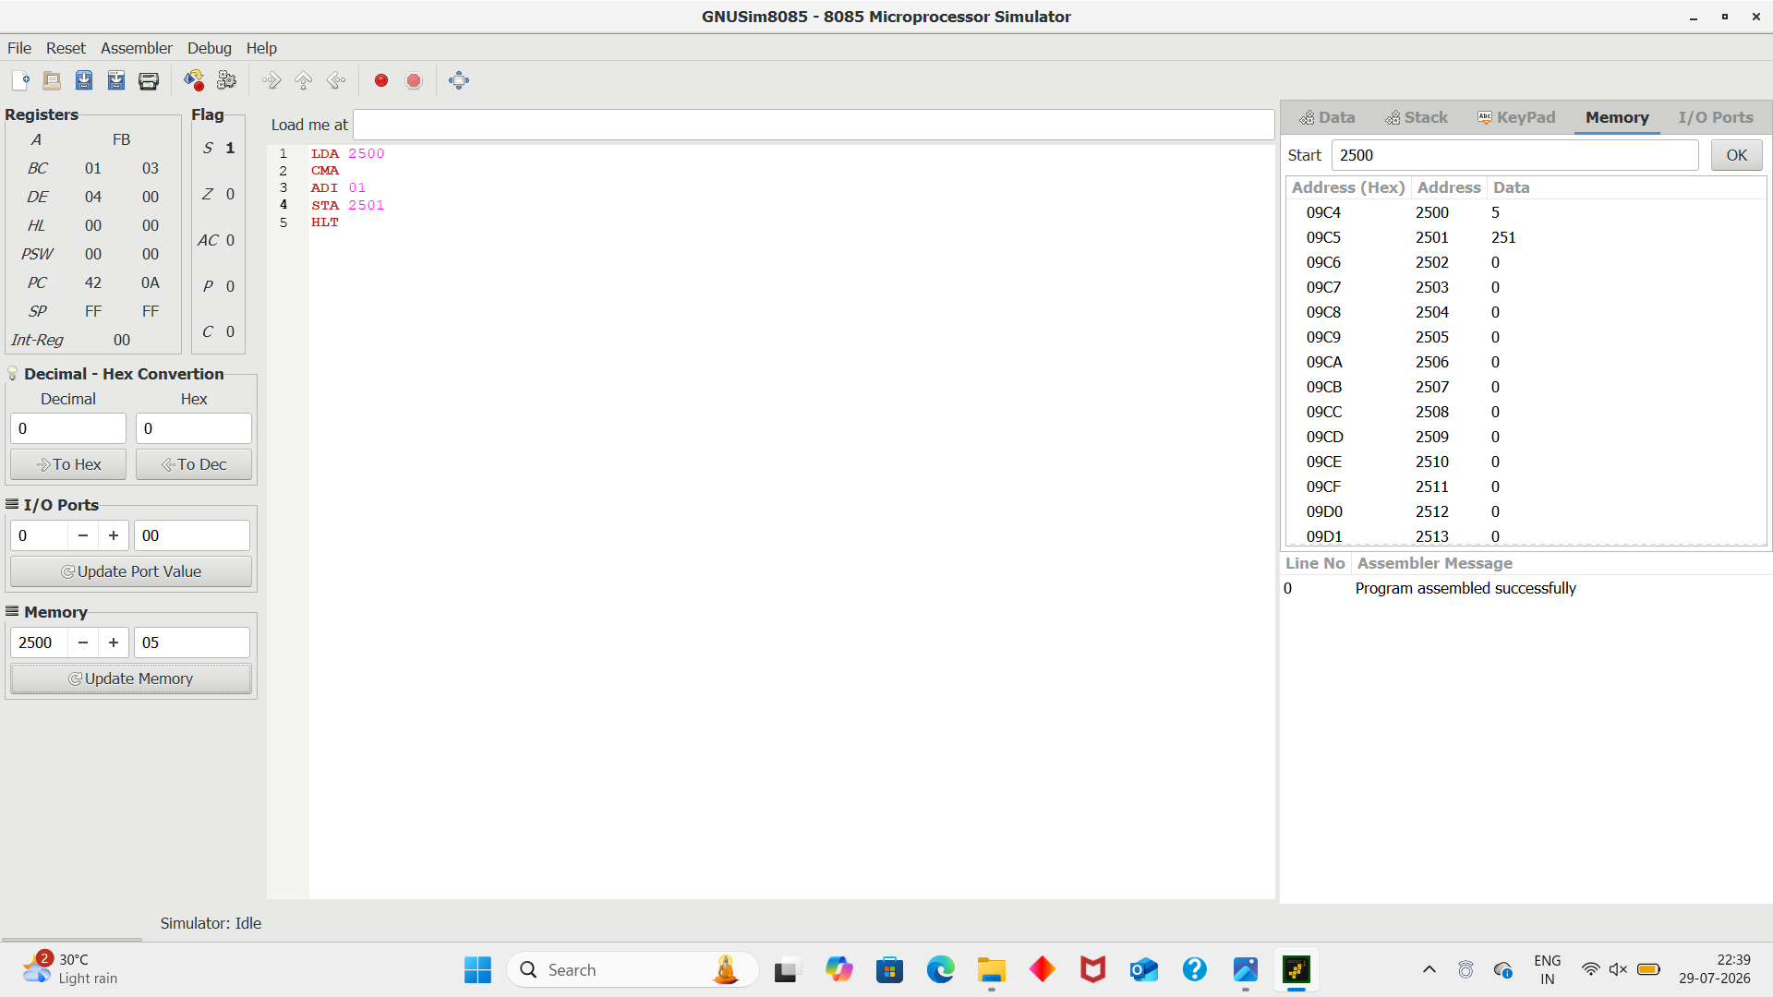
Result
Given number:
2500H = 05H
Binary representation:
05H = 0000 0101
1's complement:
1111 1010 = FAH
Add 01H:
FAH + 01H = FBH

13) Check Whether a Number is Even or Odd
Yes 👍 This screenshot is the Even/Odd number checking program.
Experiment: Check Whether a Number is Even or Odd
Aim:
To write and execute an 8085 assembly language program to determine whether a given 8-bit number is even or odd.
Procedure:
- Store the given number in memory location 2500H.
- Load the number into the accumulator using LDA 2500.
- Use ANI 01H to check the least significant bit (LSB).
- If the LSB is 0, the number is even.
- If the LSB is 1, the number is odd.
- Store the result in memory location 2501H.
- Stop the program using HLT.
Code:
LDA 2500
ANI 01
JZ EVEN
MVI A,01
STA 2501
HLT
EVEN: MVI A,00
STA 2501
HLT

Output:
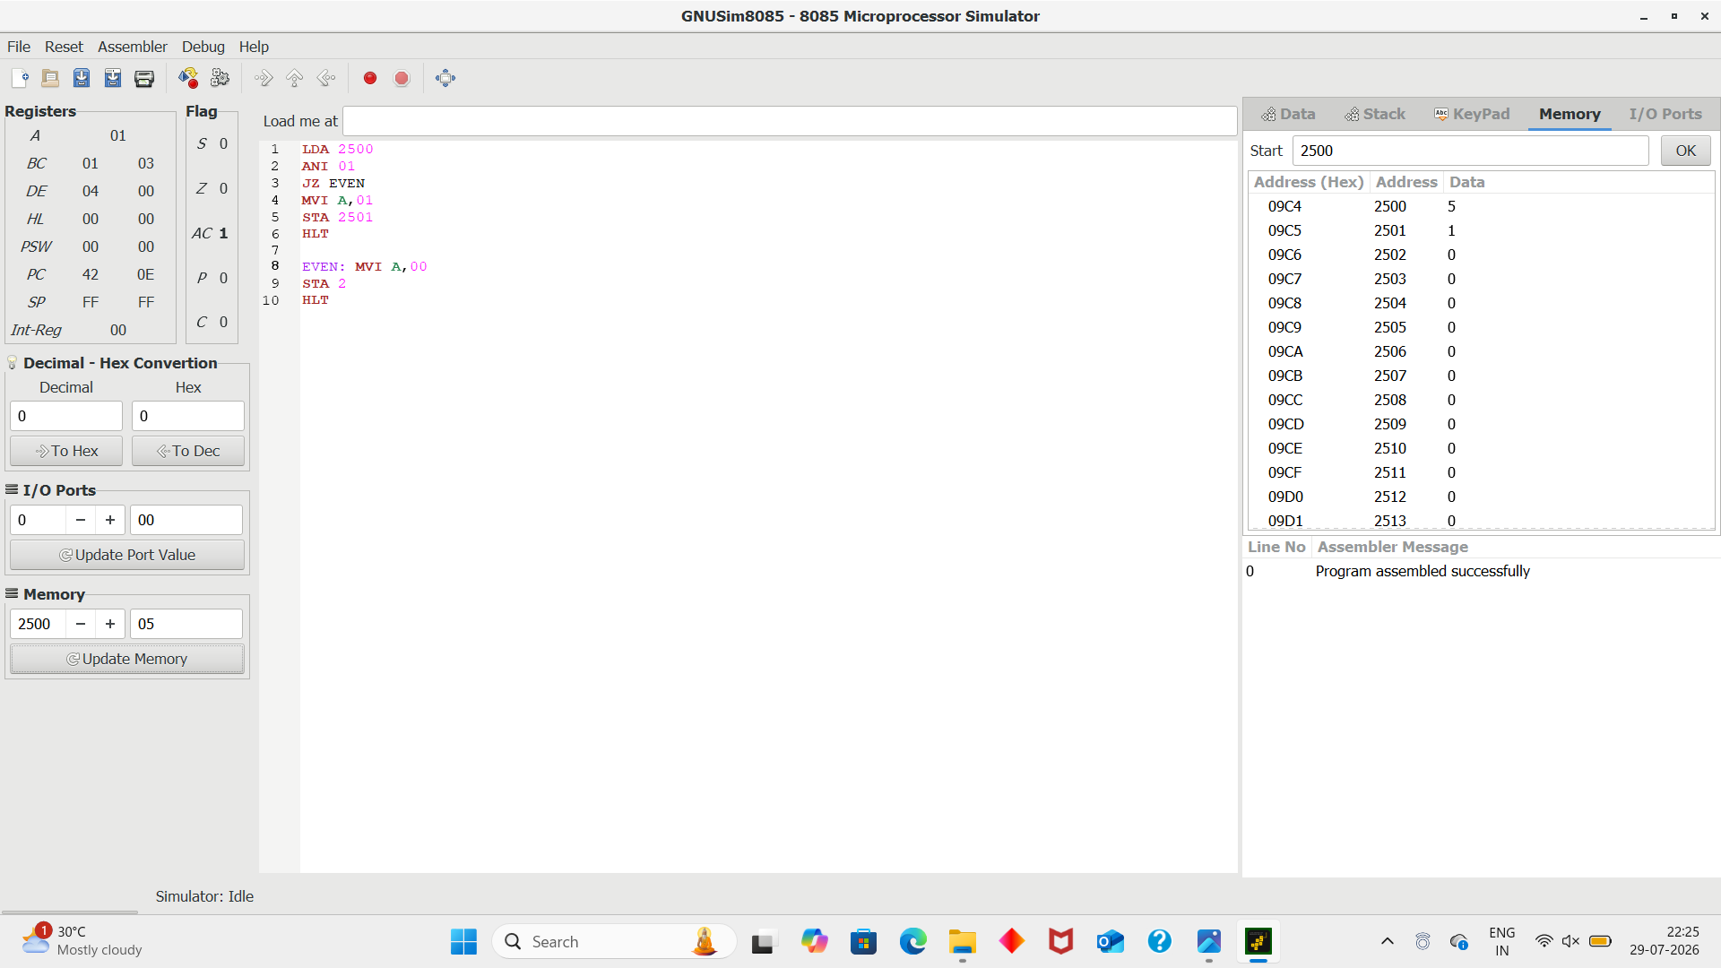
Result
For the given value in your screenshot:
Input = 05H
Binary representation:
05H = 0000 0101
The LSB is 1, so the number is odd.

